**Report on**

**Inventory Management System**

Submitted By

Shubham Yenchanwad Roll No. 31380

Bharat Tekale Roll No. 31384

Rohan Maniyar Roll No. 31387

Under the Guidance Of

Prof. A. A. Jewalikar



**Pune Institute of Computer Technology,**

**Dhankawadi, Pune - 411043**



DEPARTMENT OF COMPUTER ENGINEERING

# Pune Institute of Computer Technology

# Dhankawadi, Pune-43

**CERTIFICATE**

This is to certify that the Project report entitled

## **“Inventory Management System”**

Submitted by

Shubham Yenchanwad Roll No. 31380

Bharat Tekale Roll No. 31384

Rohan Maniyar Roll No. 31387

has satisfactorily completed a seminar report under the guidance of Prof. A.A. Jewalikar towards the partial fulfilment of third year Computer Engineering Semester II, Academic Year 2019-20 of Savitribai Phule Pune University.

Prof. A.A. Jewalikar Prof. M.S.Takalikar

Lab Prof. Head

Department of Computer Engineering

**Abstract**

The Inventory Control System in PHP is a simple project developed using PHP, JavaScript, and CSS. The project contains only the employee side. The user can manage all the management like editing, updating, adding, and removing items, customer, sale, purchase and also vendors. The user has to do all the management of this system.

In order to login to the system, the user has to login with the correct username and password. The employee can manage all the inventory information. This project makes a convenient way for the store/inventory admin to keep the records of items, customers, and orders in a proper way.

This Inventory Control System is in PHP, JavaScript, Bootstrap, and CSS. Talking about the features of this system, it contains only one section. All the editing, updating, managing products, orders, and employees are from the admin(employee) section. The design of this system is simple so that the user won’t get any difficulties while working on it.

**Introduction**

**Inventory management software** is a software system for tracking inventory levels, orders, sales and deliveries. It can also be used in the manufacturing industry to create a work order, bill of materials and other production-related documents. Companies use inventory management software to avoid product overstock and outages. It is a tool for organizing inventory data that before was generally stored in hard-copy form or in spreadsheets.

The software is used to track products and parts as they are transported from a vendor to a warehouse, between warehouses, and finally to a retail location or directly to a customer.

Without an inventory management system, the goods and products that flow through an organization will inevitably be in disarray. An inventory management system enables a company to maintain a centralized record of every asset and item in the control of the organization, providing a single source of truth for the location of every item, vendor and supplier information, specifications, and the total number of a particular item currently in stock.

 Overall, a comprehensive inventory management system offers countless benefits to companies including:

* Improved cash flow
* Better reporting and forecasting capabilities
* Reduction in storage costs (overhead)
* Reduced labour costs
* Reduction in dead stock
* Better organization
* Enhanced transparency
* Improved supplier, vendor, and partner relationships

**System Modules:**

Inventory System is in one section:

The Admin (Employee) Module:

1. Dashboard

* Item
* Purchase
* Vendor
* Sale
* Customer
* Search
* Reports

1. Item

* Product ID
* Item Number (Primary)
* Item Name
* Description
* Discount
* Stock
* Unit Price
* Image
* Status

1. Purchase

* Purchase ID (Primary)
* Vendor ID
* Item Name
* Purchase Date
* Item Number
* Vendor Name
* Unit Price
* Quantity

1. Sale

* Customer Name
* Sale ID (Primary)
* Item Number
* Customer ID
* Quantity
* Unit Price
* Discount
* Sale Date
* Item Name
* Customer Name

1. Vendor

* Vendor ID (primary)
* Full Name
* Email
* Mobile
* Phone2
* Address
* Address2
* Status
* District
* City
* Created On

1. Customer

* Customer ID (Primary)
* Full Name
* Email
* Mobile
* Phone2
* Address
* Address2
* Status
* District
* City
* Created On

1. User

* User ID (Primary)
* Full Name
* User Name
* Status
* Password

**Database Design:**

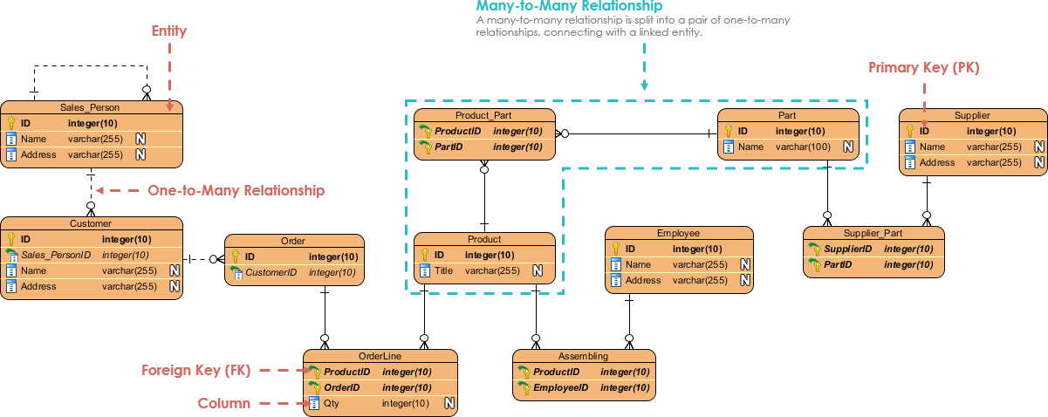

E-R Diagram:

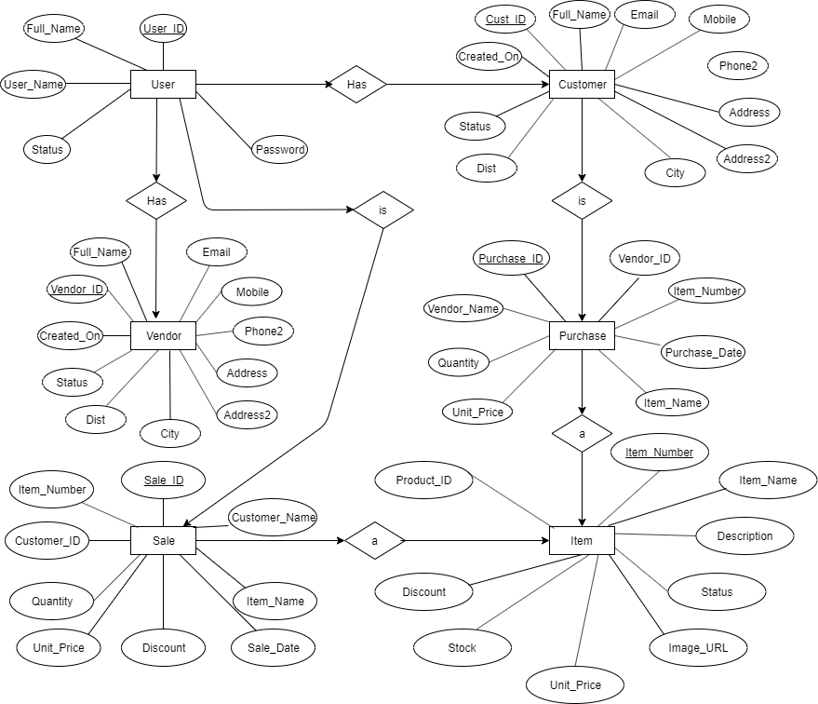

**Screenshots**

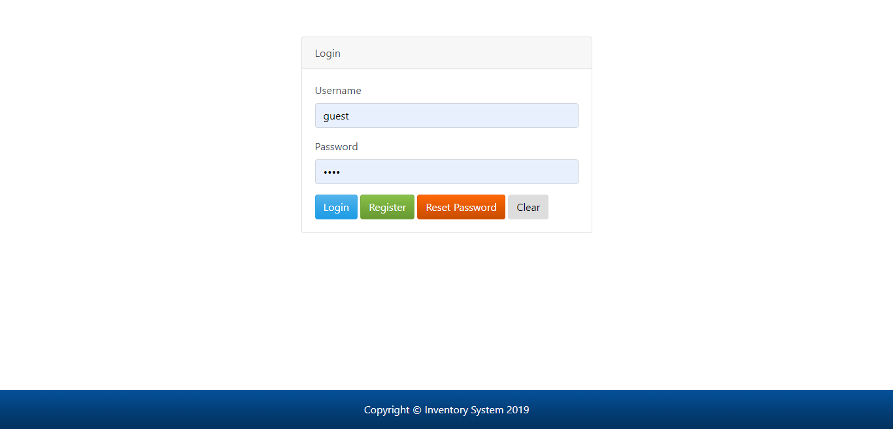

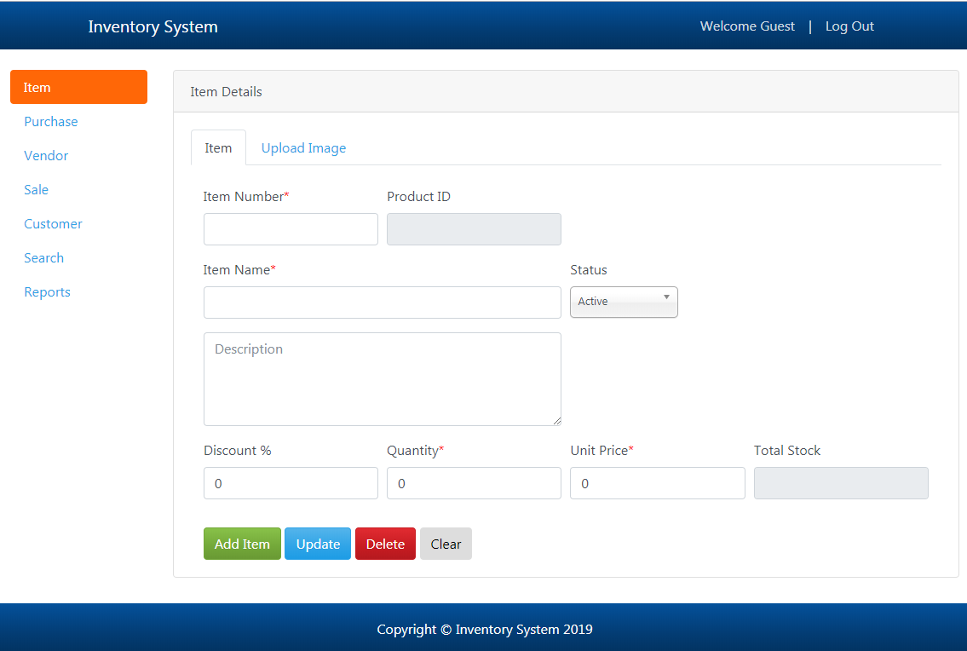

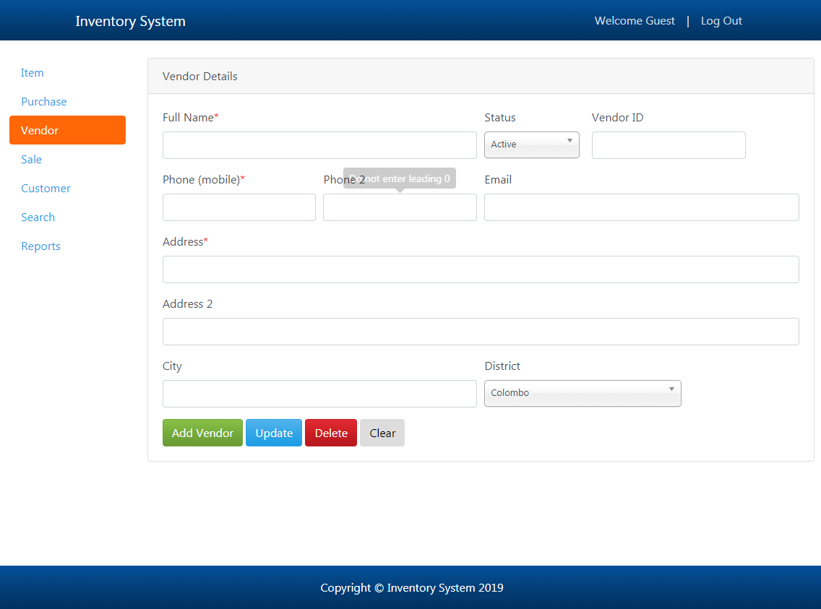

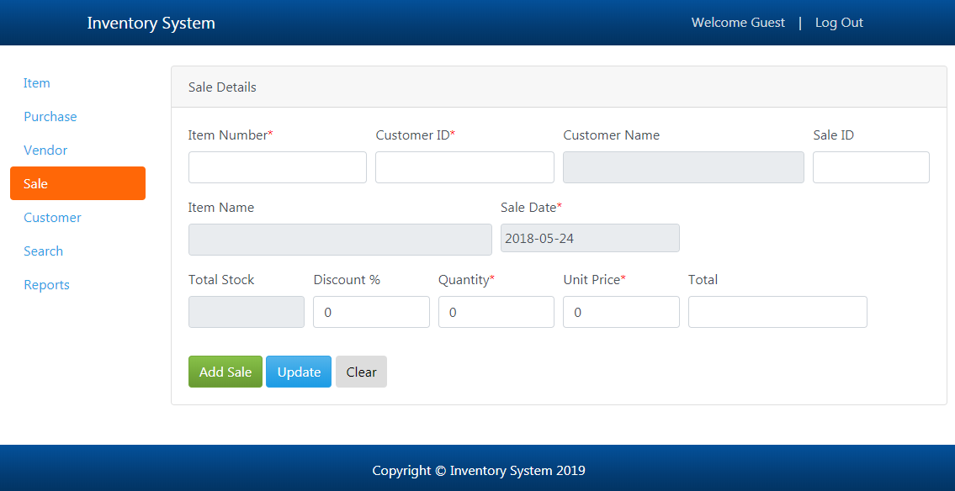

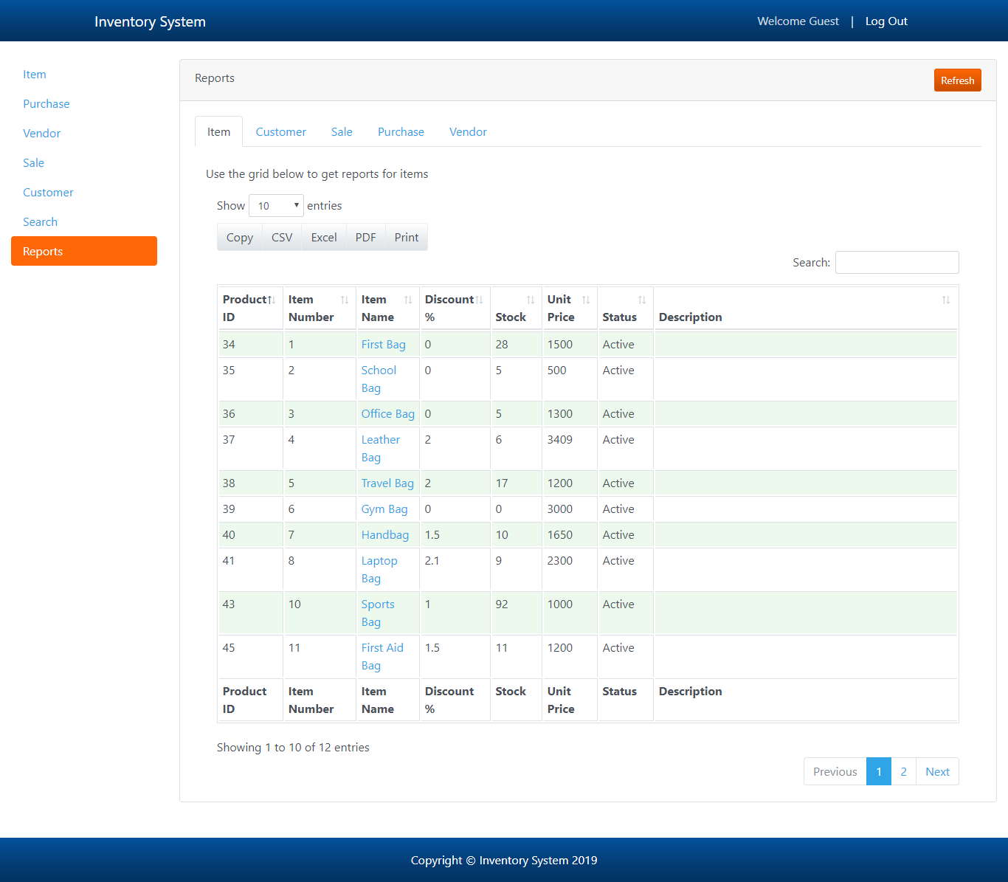

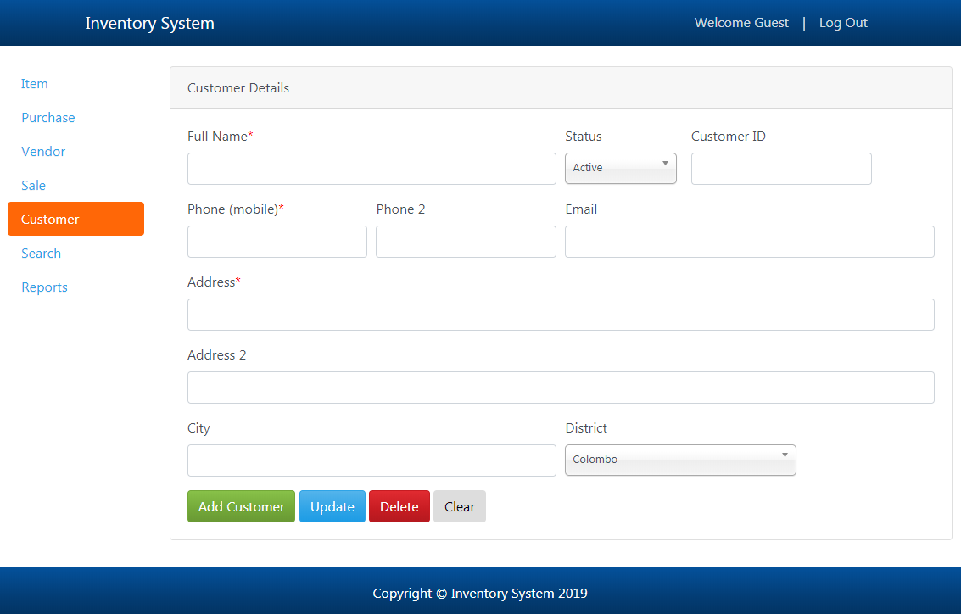

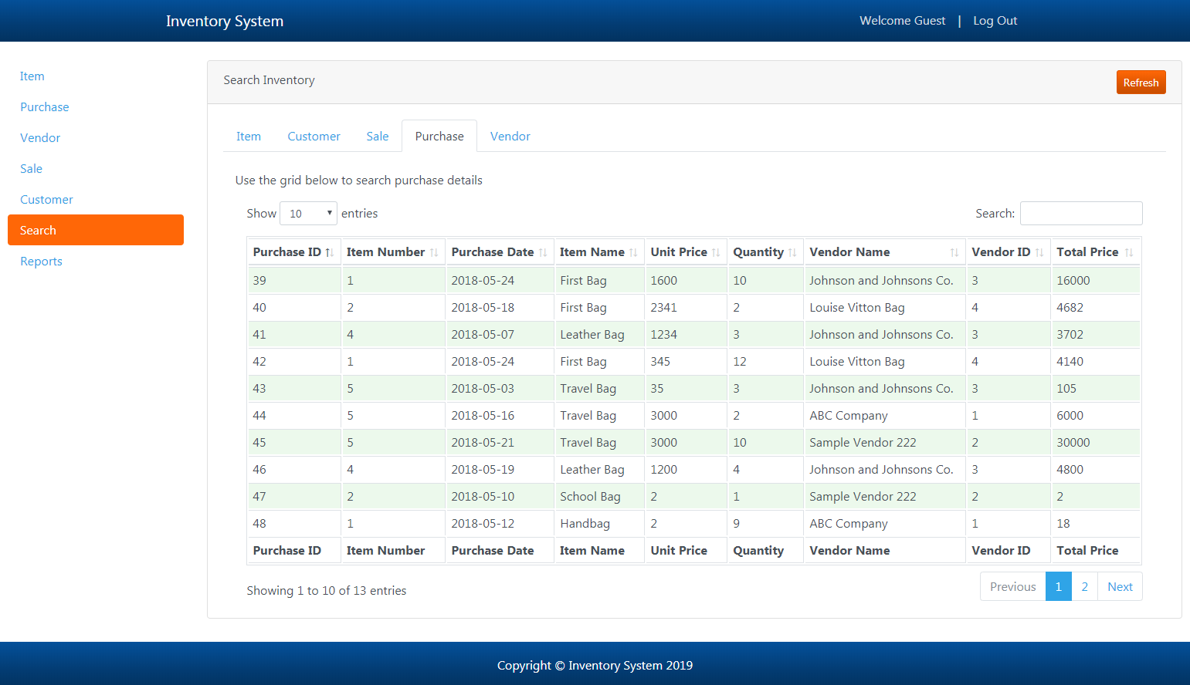

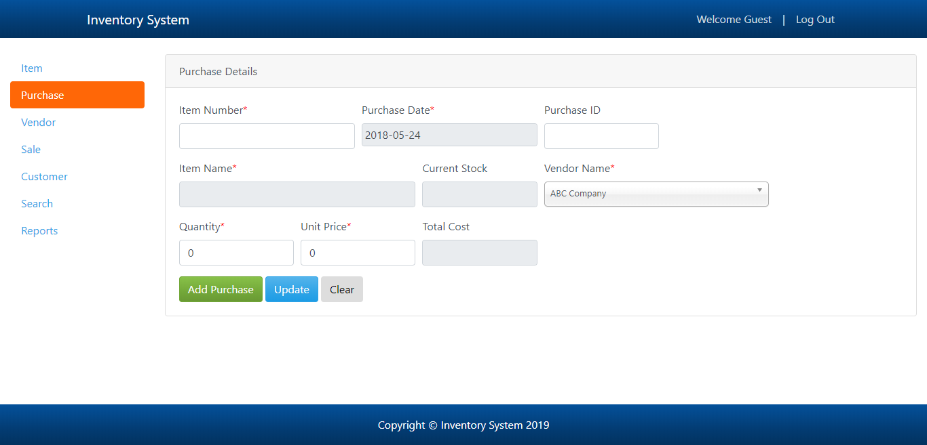

**Future scope**

In future releases, Inventory System will have the following features:

* Graphical representation of data.
* Determination of safety stock.
* Effectiveness towards running of store.
* More detailed Statistics.
* Determination of economic order quantity.
* Minimum material handling and storage cost.
* Bill generation.

**Conclusion**

Hence, through this project we have successfully implemented Inventory Management System Project as DBMS project and can be use in any warehouse/shop to manage their stock and to keep track of their business.

<?php

require 'inc/navigation.php';

?>

<!-- Page Content -->

<div class="container-fluid">

<div class="row">

<div class="col-lg-2">

<h1 class="my-4"></h1>

<div class="nav flex-column nav-pills" id="v-pills-tab" role="tablist" aria-orientation="vertical">

<a class="nav-link active" id="v-pills-item-tab" data-toggle="pill" href="#v-pills-item" role="tab" aria-controls="v-pills-item" aria-selected="true">Item</a>

<a class="nav-link" id="v-pills-purchase-tab" data-toggle="pill" href="#v-pills-purchase" role="tab" aria-controls="v-pills-purchase" aria-selected="false">Purchase</a>

<a class="nav-link" id="v-pills-vendor-tab" data-toggle="pill" href="#v-pills-vendor" role="tab" aria-controls="v-pills-vendor" aria-selected="false">Vendor</a>

<a class="nav-link" id="v-pills-sale-tab" data-toggle="pill" href="#v-pills-sale" role="tab" aria-controls="v-pills-sale" aria-selected="false">Sale</a>

<a class="nav-link" id="v-pills-customer-tab" data-toggle="pill" href="#v-pills-customer" role="tab" aria-controls="v-pills-customer" aria-selected="false">Customer</a>

<a class="nav-link" id="v-pills-search-tab" data-toggle="pill" href="#v-pills-search" role="tab" aria-controls="v-pills-search" aria-selected="false">Search</a>

<a class="nav-link" id="v-pills-reports-tab" data-toggle="pill" href="#v-pills-reports" role="tab" aria-controls="v-pills-reports" aria-selected="false">Reports</a>

</div>

</div>

<div class="col-lg-10">

<div class="tab-content" id="v-pills-tabContent">

<div class="tab-pane fade show active" id="v-pills-item" role="tabpanel" aria-labelledby="v-pills-item-tab">

<div class="card card-outline-secondary my-4">

<div class="card-header">Item Details</div>

<div class="card-body">

<ul class="nav nav-tabs" role="tablist">

<li class="nav-item">

<a class="nav-link active" data-toggle="tab" href="#itemDetailsTab">Item</a>

</li>

<li class="nav-item">

<a class="nav-link" data-toggle="tab" href="#itemImageTab">Upload Image</a>

</li>

</ul>

<!-- Tab panes for item details and image sections -->

<div class="tab-content">

<div id="itemDetailsTab" class="container-fluid tab-pane active">

<br>

<!-- Div to show the ajax message from validations/db submission -->

<div id="itemDetailsMessage"></div>

<form>

<div class="form-row">

<div class="form-group col-md-3" style="display:inline-block">

<label for="itemDetailsItemNumber">Item Number<span class="requiredIcon">*</span></label>

<input type="text" class="form-control" name="itemDetailsItemNumber" id="itemDetailsItemNumber" autocomplete="off">

<div id="itemDetailsItemNumberSuggestionsDiv" class="customListDivWidth"></div>

</div>

<div class="form-group col-md-3">

<label for="itemDetailsProductID">Product ID</label>

<input class="form-control invTooltip" type="number" readonly id="itemDetailsProductID" name="itemDetailsProductID" title="This will be auto-generated when you add a new item">

</div>

</div>

<div class="form-row">

<div class="form-group col-md-6">

<label for="itemDetailsItemName">Item Name<span class="requiredIcon">*</span></label>

<input type="text" class="form-control" name="itemDetailsItemName" id="itemDetailsItemName" autocomplete="off">

<div id="itemDetailsItemNameSuggestionsDiv" class="customListDivWidth"></div>

</div>

<div class="form-group col-md-2">

<label for="itemDetailsStatus">Status</label>

<select id="itemDetailsStatus" name="itemDetailsStatus" class="form-control chosenSelect">

<?php include('inc/statusList.html'); ?>

</select>

</div>

</div>